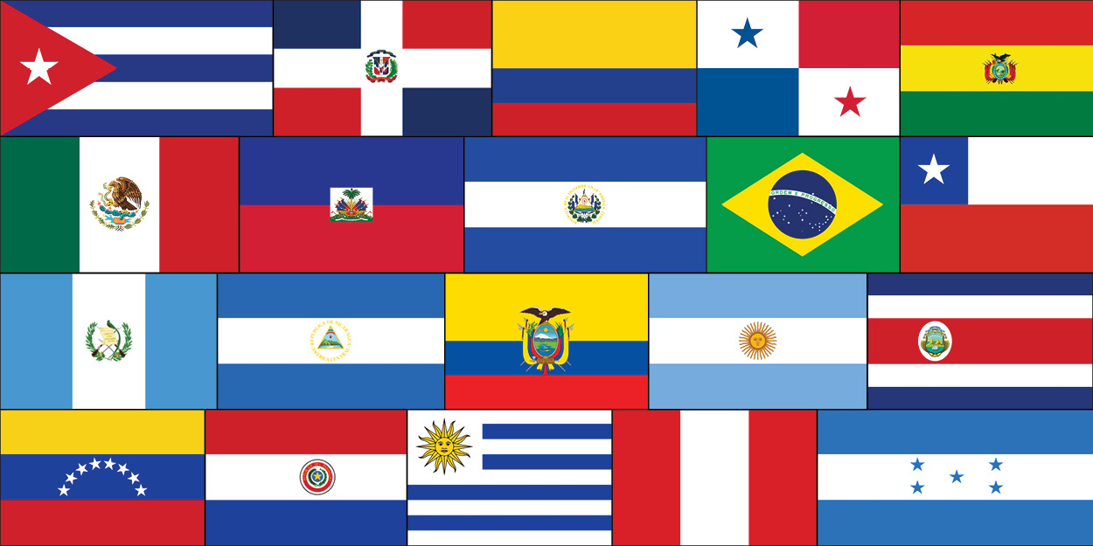
Hispanic Heritage Project
Ms. Maes
Choose one of the cultural projects listed in this letter. Follow the directions carefully and do your best work, as this project is worth 15% of your grade.
1. Travel Brochure
Research a Hispanic country and type a works cited with at least 3 sources to turn in. Use your research to create a detailed travel guide/brochure. Include the following information:
-weather/climate
-historical sites
-government
-population
-leisure activities
-food
-holidays
-traditions
Try to convince your readers to visit this country. Be sure that your brochure has pictures. You may draw them yourself or find them on line, from magazines or in travel agency brochures. Create a colorful brochure promoting travel to this country.
2. Biography Research
Choose a famous Latino figure (artist, sport figure, scientist, historical figure, etc.). This Hispanic figure that you choose will be the topic of your research paper. Type a well-written 2-3 page report in English (Double-spaced-1 inch margins, 12 pt. Font.) Attach a works cited page with at least 3 sources.
Works Cited Websites:
http://www.citationmachine.net/
http://www.easybib.com/
- Please ensure that either in the travel brochure or research paper that you include the three different websites you received your information from.
Due Date: 10/05/2017-10/06/2017

